How to Generate Redundancy Report

Introduction
Flay is a tool in ROR which can be used to find out the redundant code in our whole ROR
application,by comparing each and every file. Flay compare all HTML file and .rb file and finds out
the exact location where redundant code is traced out. It gives result for similar as well as identical
codes. Similar codes are those who have minor changes and rest whole code is same but identical
codes are those which are exactly same.

Purpose of the document
This document gives the basic knowledge on how to find redundant code in ROR application using
Flay tool

Scope of the Document
This document contains all steps to implement the flay tool in any application and to generate the flay result.
Also it covers the various advantages and few disadvantages of the flay tool.

References
http://ruby.sadi.st/Ruby_Sadist.html

Abbreviations, Definitions, terminologies
NA

Organization of Document
NA

Technical Requirements
Technology : Ruby, Ruby on Rails
Gems : flay

General Description

How to use Flay
It is available as gem so can be installed as gem.
1)for rails2-
gem install flay

2)for rails3-
In gem file write gem 'flay'
Then run bundle install.

This gem is available in RubyGems.org also so if there is any version error for flay we can refer
this and can get latest version of flay.

Describing Code with RSpec
Requirements:-
1] A user should have a username that they can log in with
2] A user should have an email address
3] A user should have a password
4] A user should have a password between 6 and 12 characters in length
5] A user can optionally have a first name

Create a new Rails Application:-

rails login_system -d postgresql
cd login_system

Install rspec and rspec-rails plugins for Rails >= 2.1.0:-

ruby script/plugin install git://github.com/dchelimsky/rspec.git -r 'refs/tags/1.2.9'
ruby script/plugin install git://github.com/dchelimsky/rspec-rails.git -r 'refs/tags/1.2.9'
ruby script/generate rspec

For Rspec we need the database defined as "test"
# Warning: The database defined as "test" will be erased and regenerated from your development database when you run "rake". Do not set this db to the same as development or production.

test:
adapter: postgresql
encoding: utf8
reconnect: false
database: login_system
username: postgres
password: admin
host: 192.168.1.57

ruby script/generate rspec_scaffold user username:string password:string email:string first_name:string

rake db:create
rake db:migrate

Now take your Requirement one by one and write Rspec for it.

1] A user should have a username that they can log in with

Now open file login_system/spec/models/user_spec.rb

before(:each) do
@user = User.new
end

it "should be invalid without a username" do
@user.should_not be_valid
@user.errors.on(:username).should == "is required"
@user.username = 'someusername'
@user.should be_valid
end

NOW “rake spec” to run the spec you write and, naturally, it fails.
To Make above test pass write following in user model

validates_presence_of :username, :message => 'is required'

2] A user should have an email address

it "should be invalid without a email address" do
@user.should_not be_valid
@user.errors.on(:email).should == "is required"
@user.email = 'salil@cipher-tech.com'
@user.should be_valid
end

To Make above test pass write following in user model

validates_presence_of :email, :message => 'is required'

3] A user should have a password

it "should be invalid without a password" do
@user.password=nil
@user.should_not be_valid
@user.errors.on(:password).should == "is required"
@user.password = 'somepassword'
@user.should be_valid
end

To Make above test pass write following in user model

validates_presence_of :password, :message => 'is required'

4] A user should have a password between 6 and 12 characters in length

it "should be invalid if password is not between 6 and 12 characters in length" do
@user.attributes = valid_user_attributes.except(:password)
@user.password = 'abcdefghijklm'
@user.should_not_be_valid
@user.password = 'abcde'
@user.should_not_be_valid
@user.password = 'abcdefg'
@user.should_be_valid
end

To Make above test pass write following in user model

validates_length_of :password, :in => 6..12, :allow_nil => :true

5] There should be a method which authenticate and returns user if proper username, password combination is given

it "should be invalid if username password is not proper" do
User.authenticate('salil@cipher-tech.com', "wrongpassword").should be_nil
User.stub!(:authenticate).and_return(@user)
User.authenticate('salil@cipher-tech.com', "abcdefgh").should == @user
end

To Make above test pass write following in user model

def self.authenticate(username, pass)
user = find(:first, :conditions=>["username = ? ", username])
return user
end

here we can refactor our authenticate method to make it more modular as follows

def self.authenticate(username, pass)
user = find(:first, :conditions=>["username = ? ", username])
end

RCov
RCov is a code coverage tool. The idea is that you run your specs and rcov observes what code in your application is executed and what is not. It then provides a report listing all the lines of code that were never executed when you ran your specs, and a summary identifying the percentage of your codebase that is covered by specs.

Commands for Rspec/Rcov:-
1] To run all the specs with coverage
rake spec:rcov

After running this command a folder with html (Code Coverage) files are create in RAILS_ROOT.

2] To run specific spec file with coverage
rake spec:rcov SPEC=spec/models/some_class_spec.rb

After running this command a you can see a Code Coverage of files at RAILS_ROOT/coverage/app-models-some_class_rb.html

3] To run all the specs w/o coverage
rake spec

4] To run specific spec file w/o coverage
rake spec SPEC=spec/models/model_spec.rb

Checking if your specs are complete
$ cd spec/models
$ ls | wc -l # 56; number of models that need testing
$ egrep ^[[:space:]]+it *.rb | wc -l # 544; number tests written to test the 56 models
$ grep '\.should' *.rb | wc -l # 51; number of tests that actually test anything
$ grep -L '\.should' *.rb | wc -l # 51;number of models that have not been tested at all
$ grep -l '\.should' *.rb | wc -l # 5; number of models that have been tested
$ grep -l '\.should' *.rb # names of models(files) that have been tested
$ grep -L '\.should' *.rb # names of models(files) that have not been tested

2.4 Diagrams
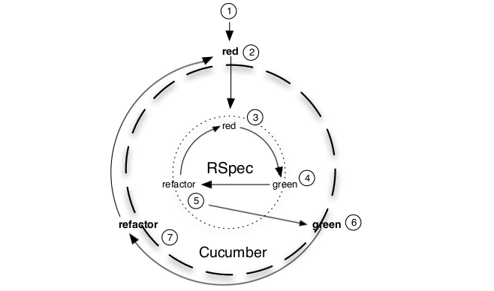
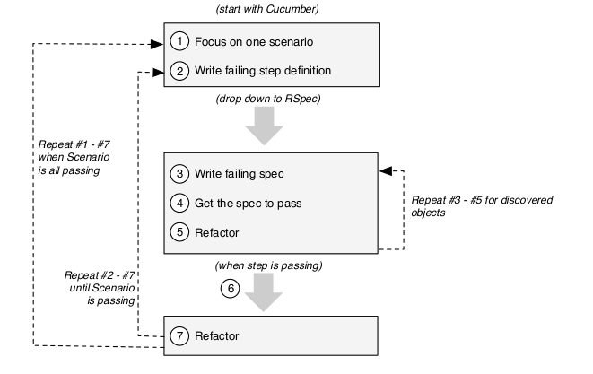

Disadvantages of Rspec
1] Production time goes high
2] Can't guarantee there is no Code Redundancy

